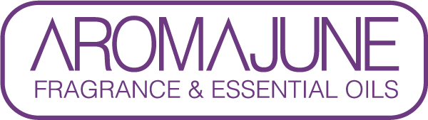

DATE : {{DATE}}
TO : {{CUSTOMER}}
SUBJECT : VEGAN STATEMENT
PRODUCT NAME : {{PRODUCT}}

JADORO LR, manufactured by AROMAJUNE, certifies that the mentioned products have not been tested on animals since March 1, 2013.

We herewith certify that, to the best of our knowledge, we have never carried out any animal testing on the Product and its raw materials and we have also never entrusted any animal test on the Product to any third party.



